Peanut shelling machine/peanut sheller
Description
Peanut shelling machine is designed to clean raw, sun-dried in shell peanut,split the hard shell and get the red skin peanut. Peanut sheller have two part: one is de-stoner and another is shelling machine.
Put peanut in shell into de-stoner separate the stones by the gravity. and then is conveyed to the feed hopper in the shelling machine by the stoning machine. When it meets 1# drum first, the rotating rasp bar working against the fixed grid notch-board detaches the shell from the nut. As they go further and drop from the front sifter, most shells will be blown outside of the machine as they pass the ventilation tube. When the shelled nut, together with few of the un-shelled peanuts drop to the separating sieve, the kernels would go to the surface to the outlet and reach the container. Meanwhile, the remaining un-shelled peanut would go under the sieve to the second outlet and reach the 2# drum, conveyed by the air blower, for repeat shelling against the thin grid notch-board. After this process, they would again go through the separating sieve to detach the shell from the kernel. The nut and shell would be separated thoroughly after the whole process.
Features
Stable performance & strong durability
High efficiency & minimum split ratio
Easy operation & low maintenance
Peanut sheller increases productivity and saves manpower, it promotes the raw peanut processing from family to industrial scale.
Technical information
Model | TK-2000 | TK-3000 | TK-5000
Voltage | 380V 50HZ 3Phase or 220V 60HZ 3Phase
Power | 21kw | 31kw | 43kw
China Peanut Input Capacity | 2t/h | 3t/h | 5t/h
China Peanut Output Capacity | 1.5-2t/h | 2-2.5t/h | 3.5-4t/h
Peeling Rate | 99% | 99% | 99%
Breaking Rate | 2% | 2% | 2%
Weight | 1300kgs | 1600kgs | 2000kgs
Size | 2.2x1.3x2.6m(shelling) 2.1x1.1x1.7m(sorting) | 2.3x1.5x2.6m(shelling) 2.1x1.2x1.7m(sorting) | 2.8x1.6x2.8m(shelling) 2.2x1.2x1.7m(sorting)

Finished product :
Peanut in shell after shelling
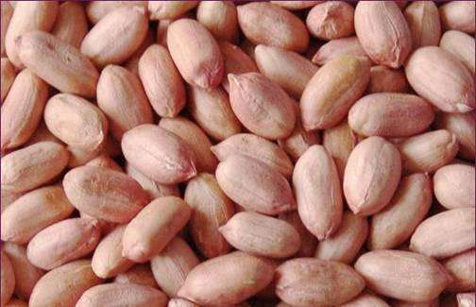
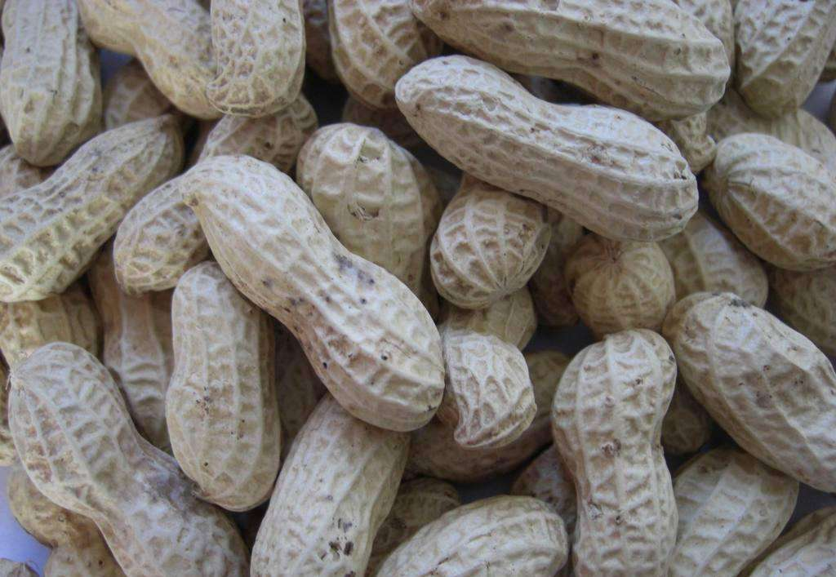

Drawing
